<https://drive.google.com/drive/folders/1inaf-IDNsqjT2oxk21VJyF7K1ykD0EKI?usp=sharing>

**QUESTION 3** :

1. **What was the highest number of people travelled in which year?**

[bigdatamind43843@ip-10-1-1-204 ~]$ hadoop fs -put airlines.csv

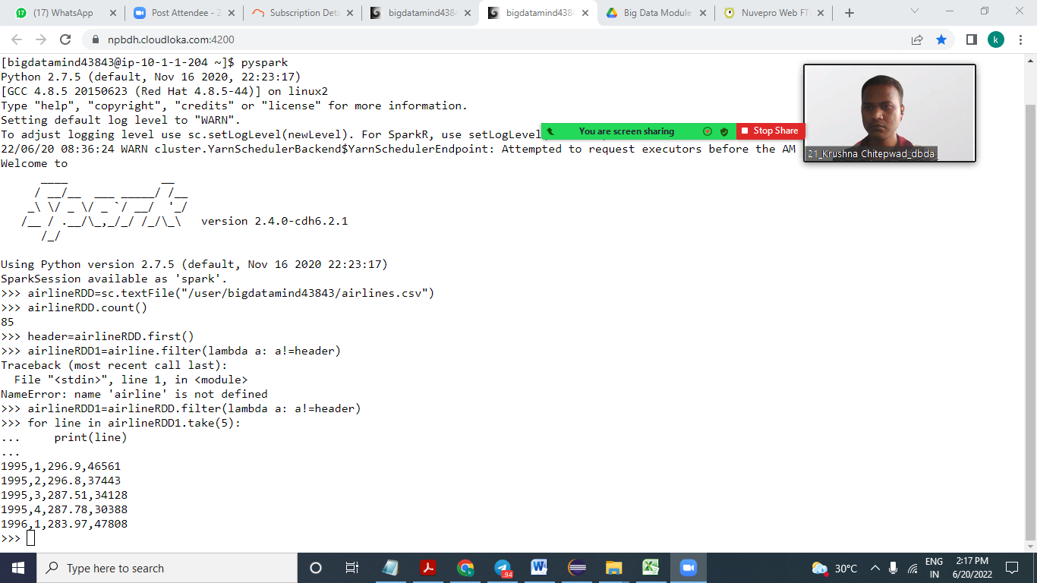

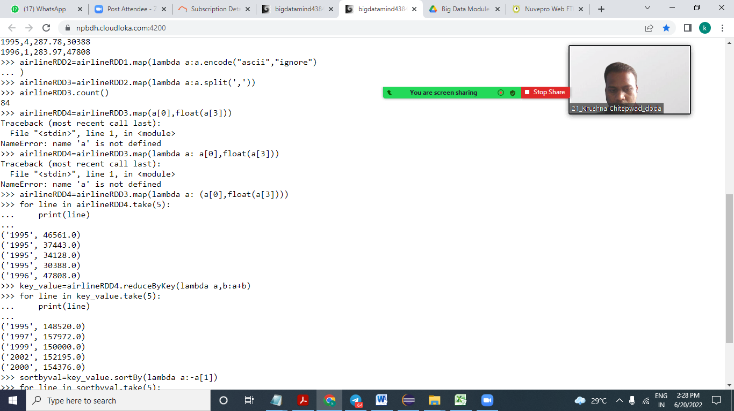

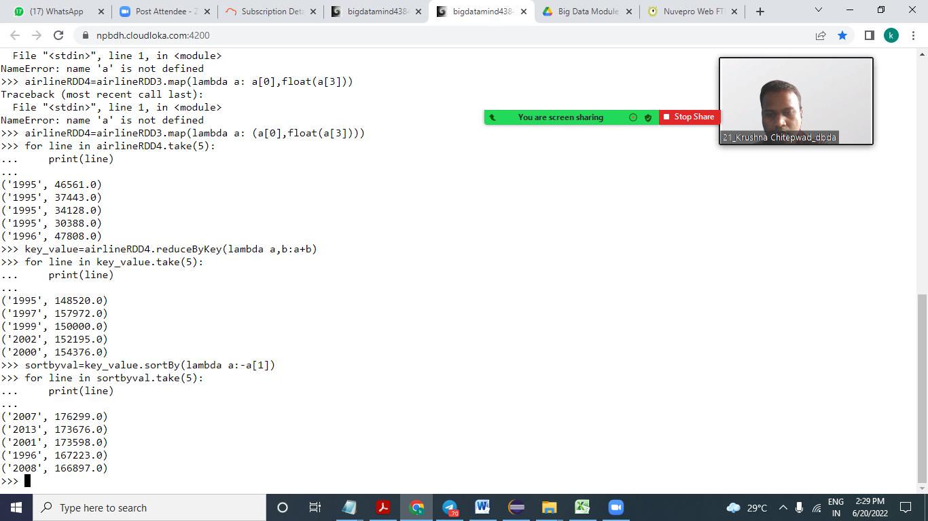

Highest number of people triveled in year 2013.

1. **Identifying the highest revenue generation for which year**

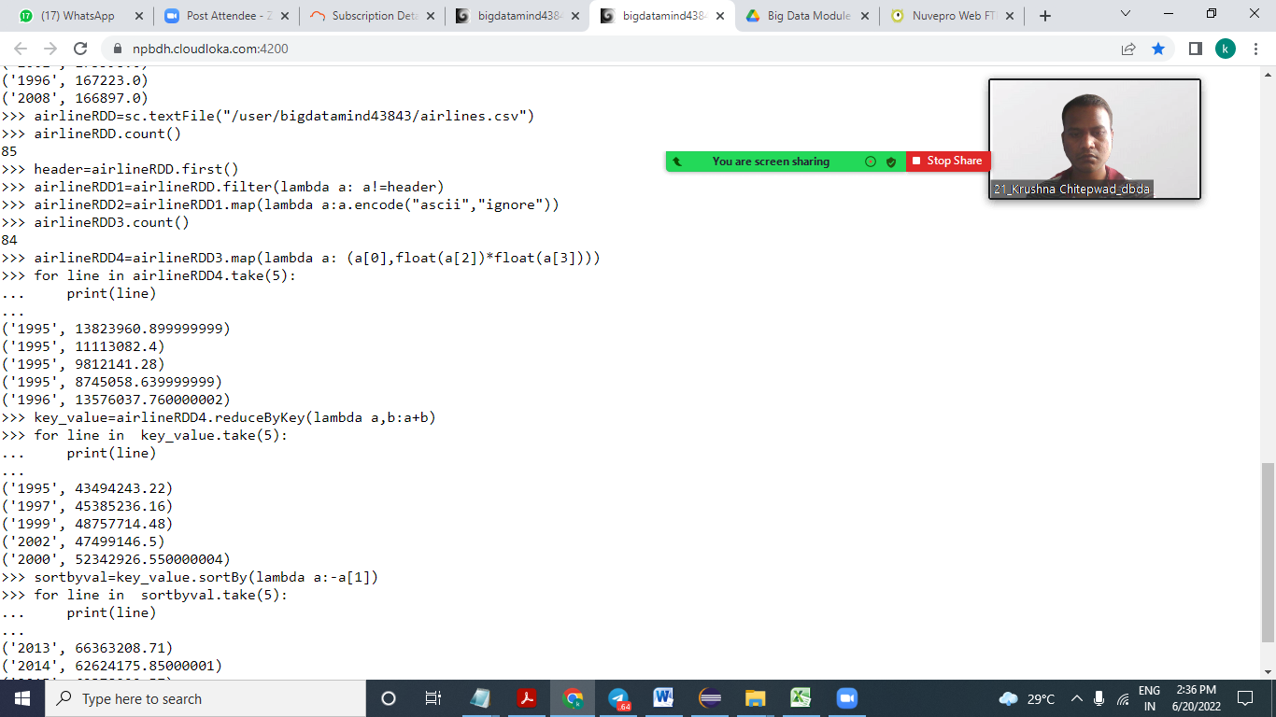

Highest revenue generation year is 🡪 2013

1. **Identifying (Common group)**

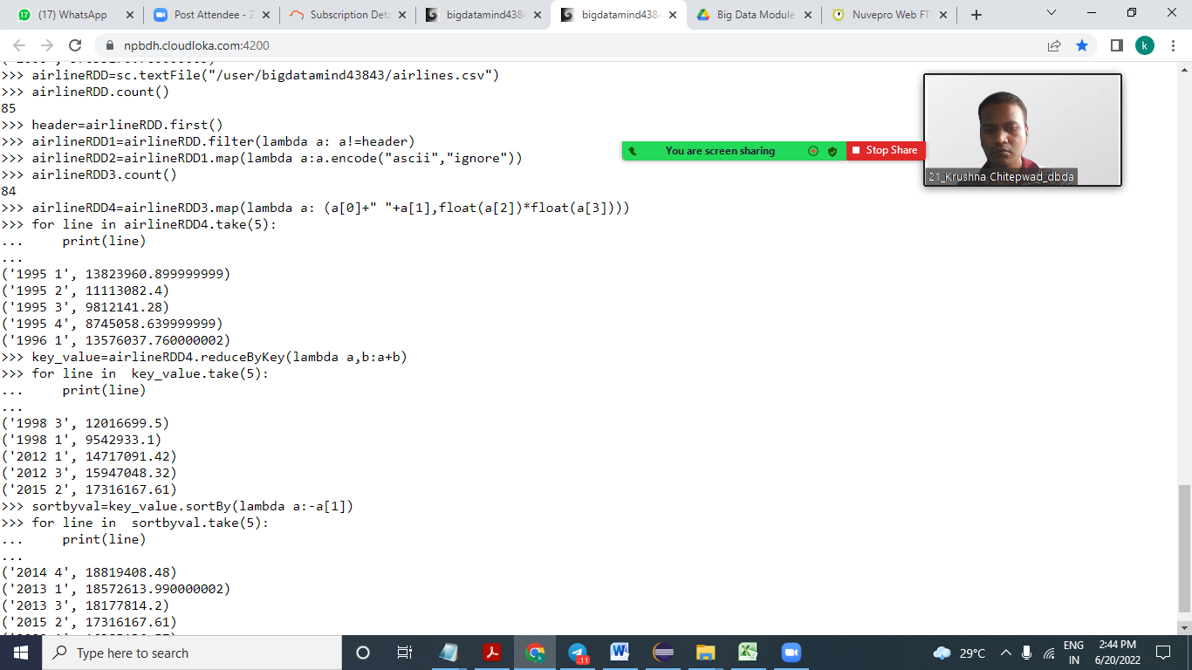

**the highest revenue generation for which year and quarter**

**🡪2014 quarter 4.**

**Question 2 : Find all time High price for each stock**

HIVE --CUSTOMER TABLE

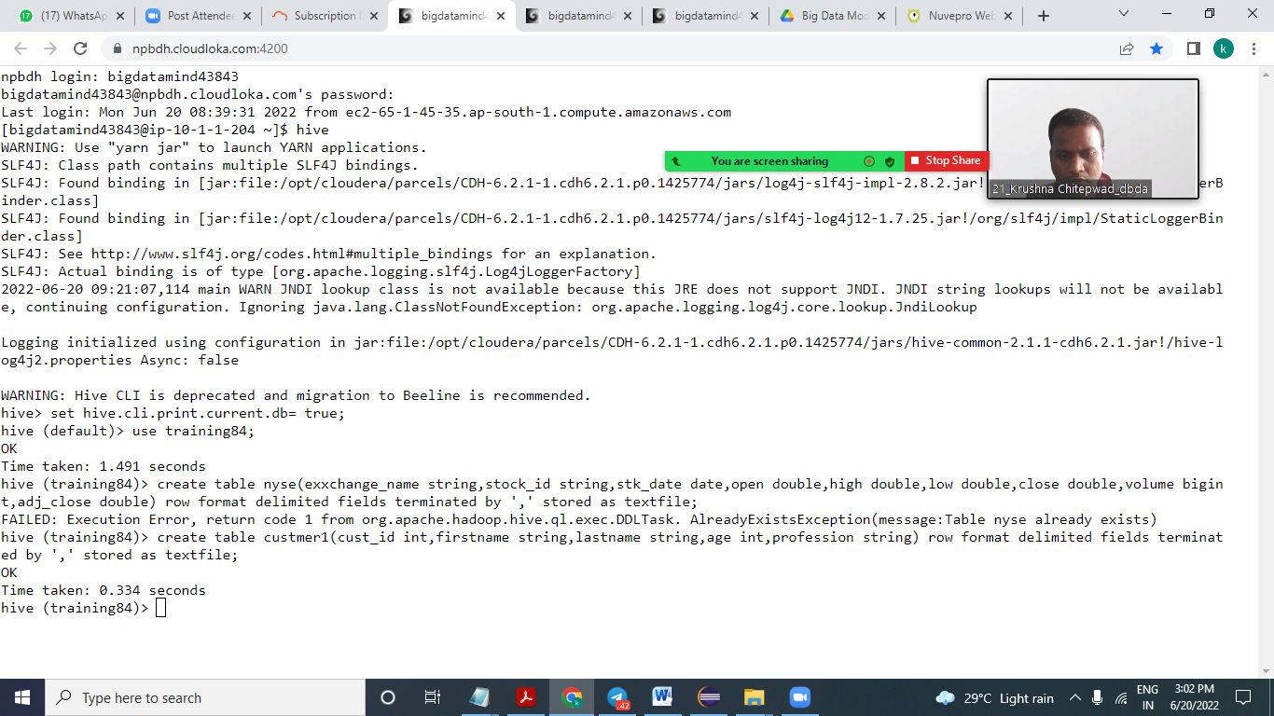

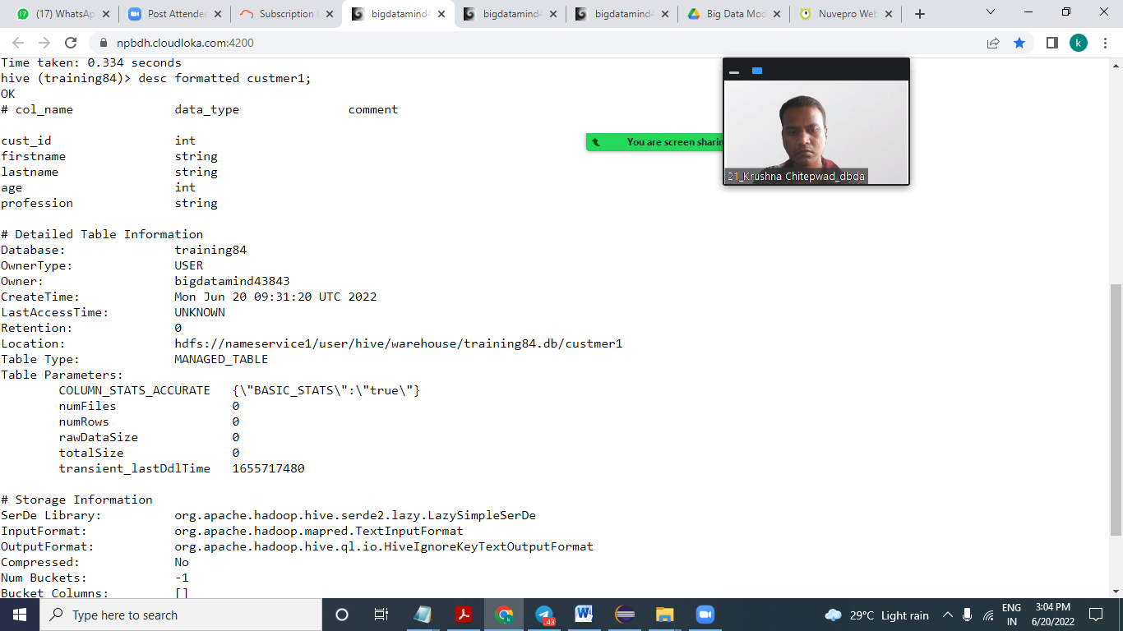

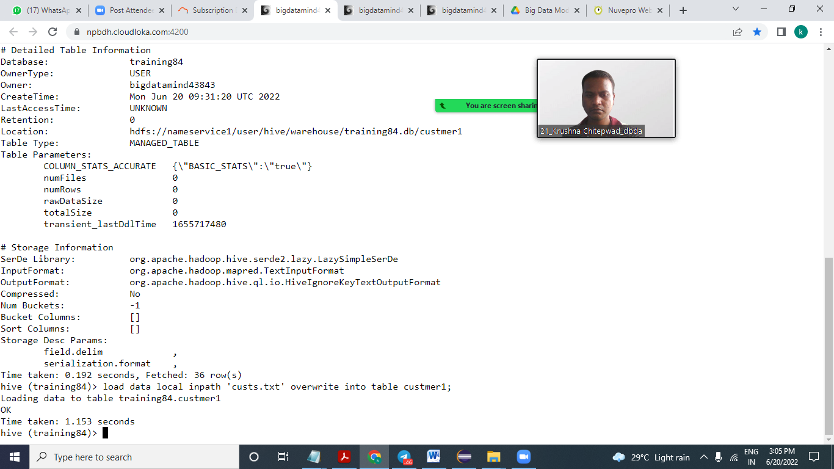

**1) Write a program to find the count of customers for each profession.**

hive (training84)> select count(profession),profession from custmer1 group by profession;

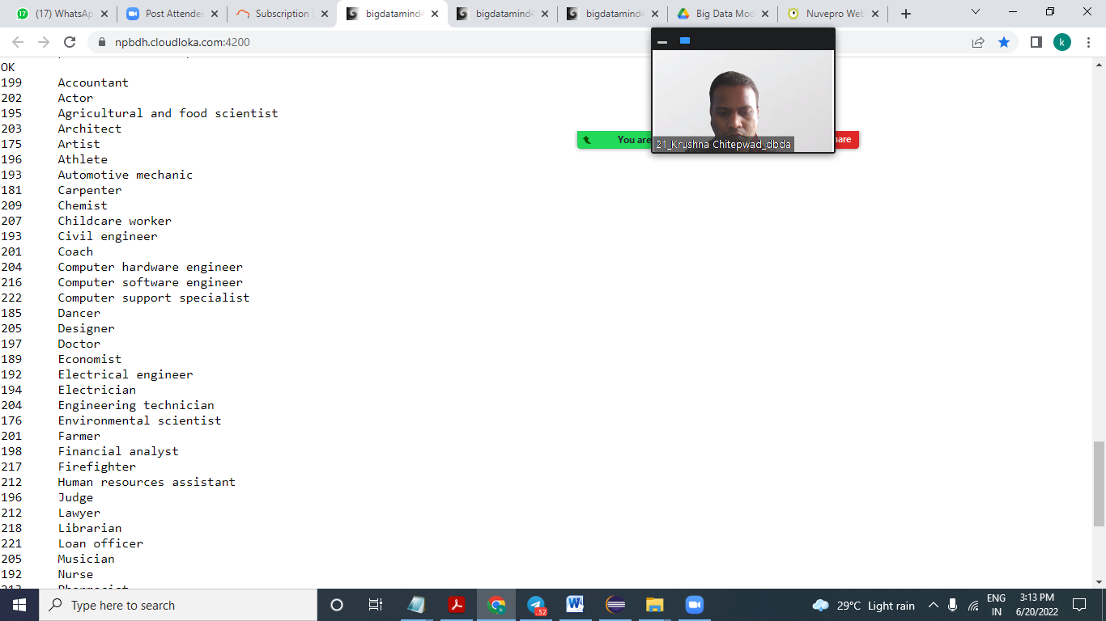

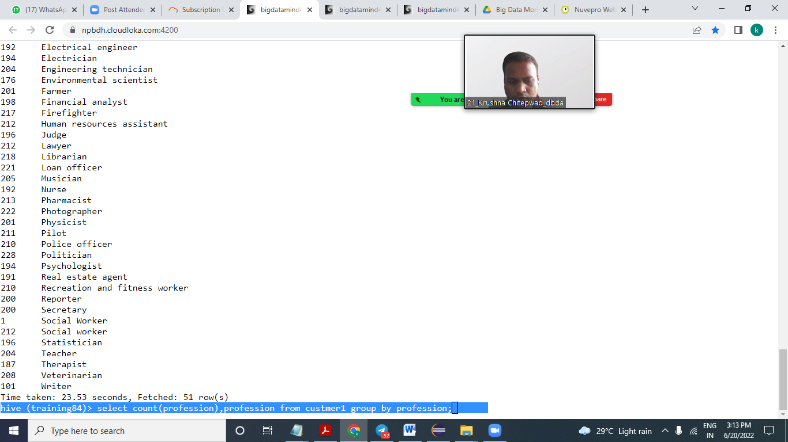

hive (training84)> select count(*) from custmer1;

* Distinct professions are 51.

**2) Write a program to find the top 10 products sales wise**

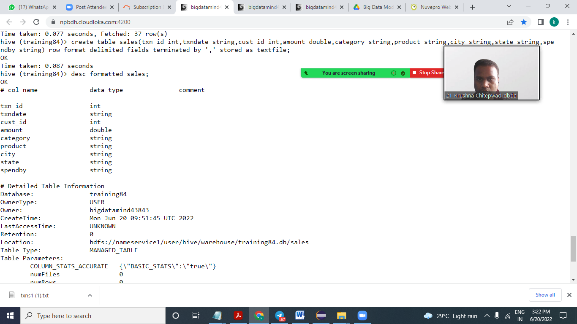

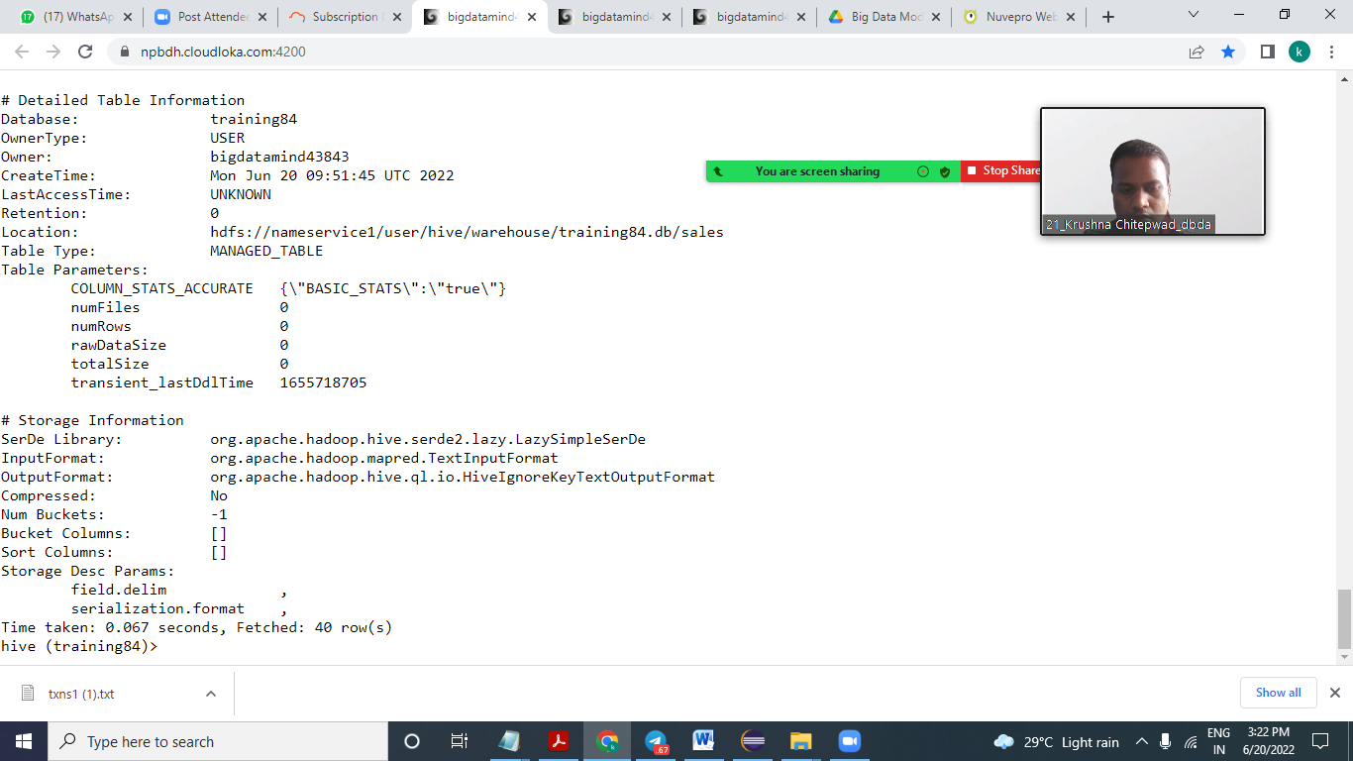

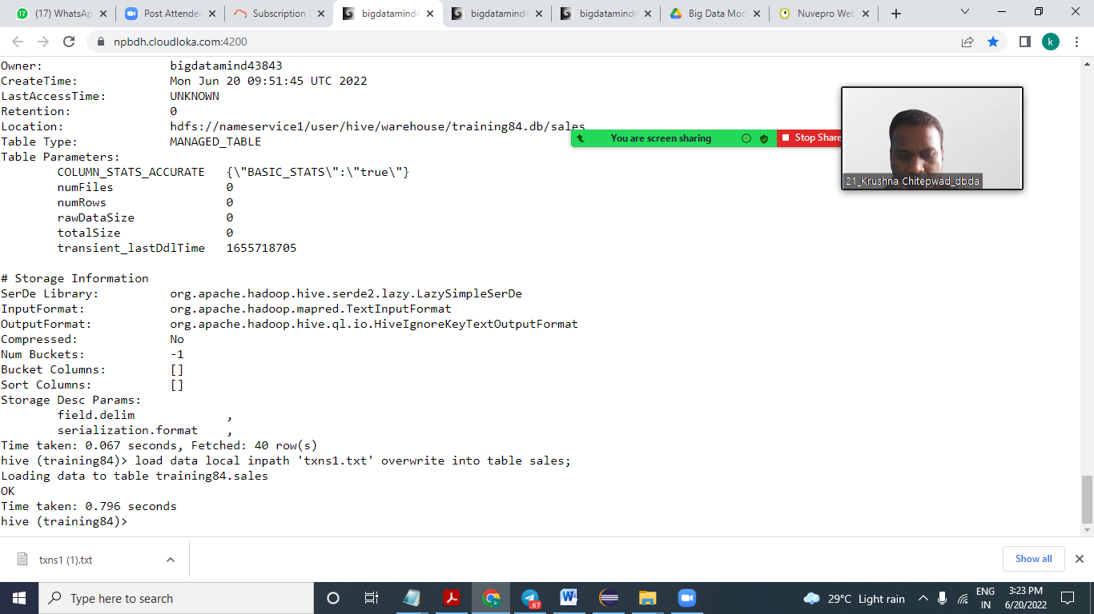

hive (training84)> select product ,sum(amount) as total from sales group by product order by total desc limit 10;

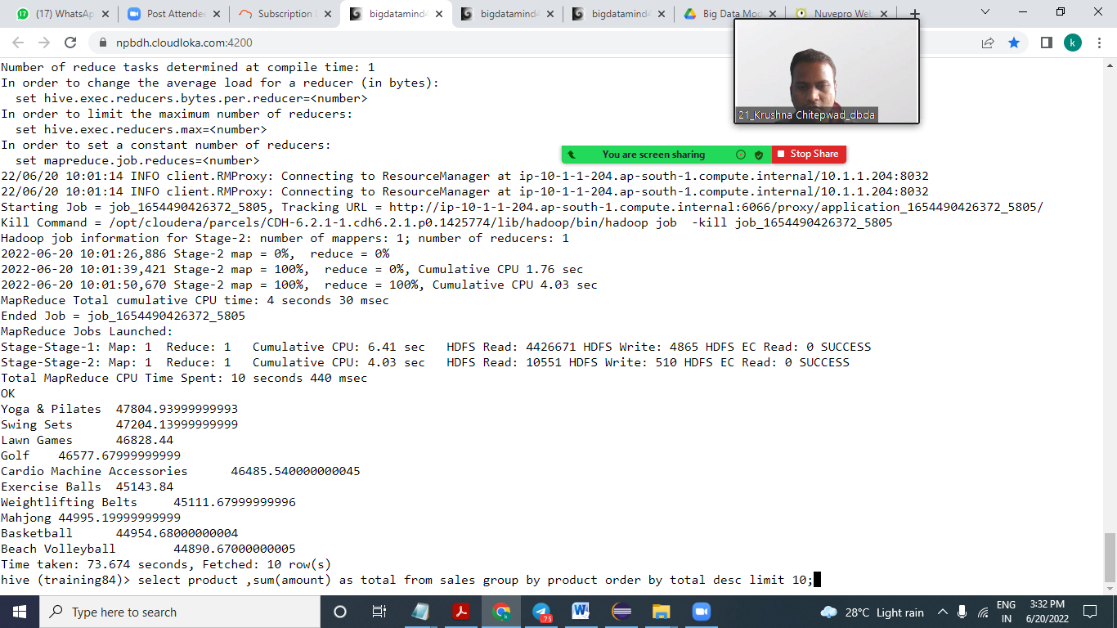

1. **Write a program to create partiioned table on category**

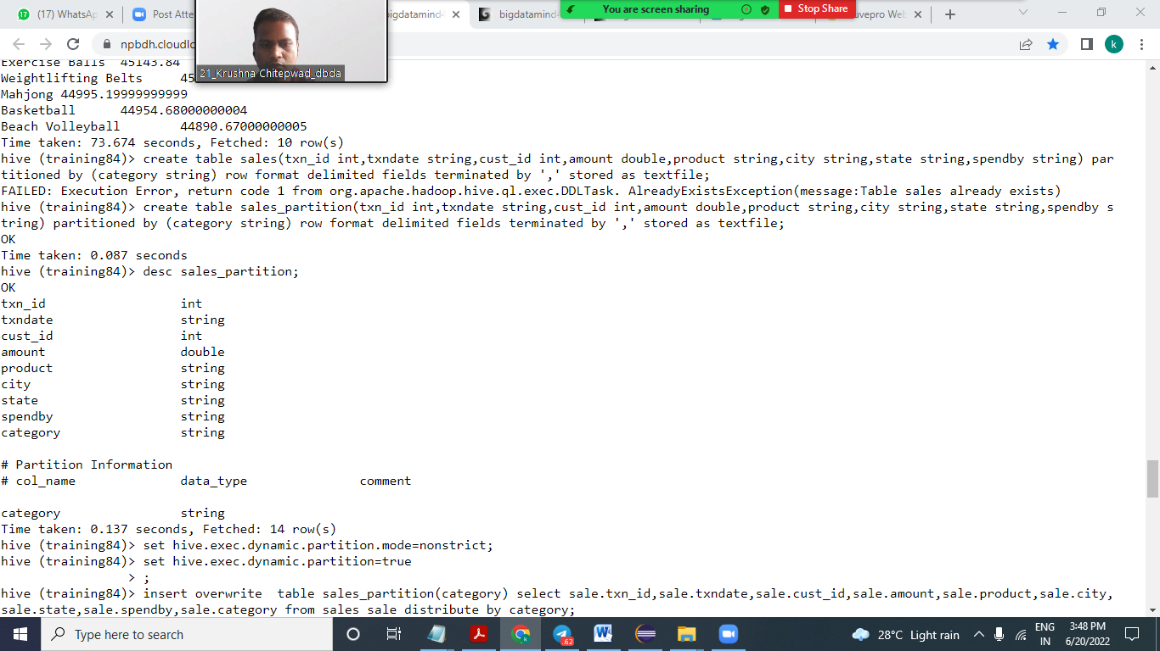

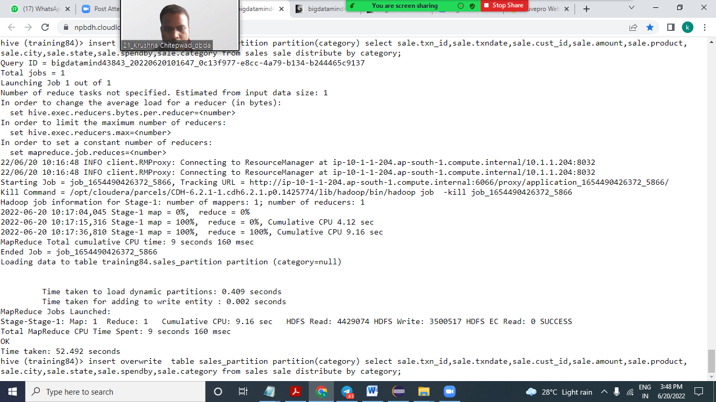

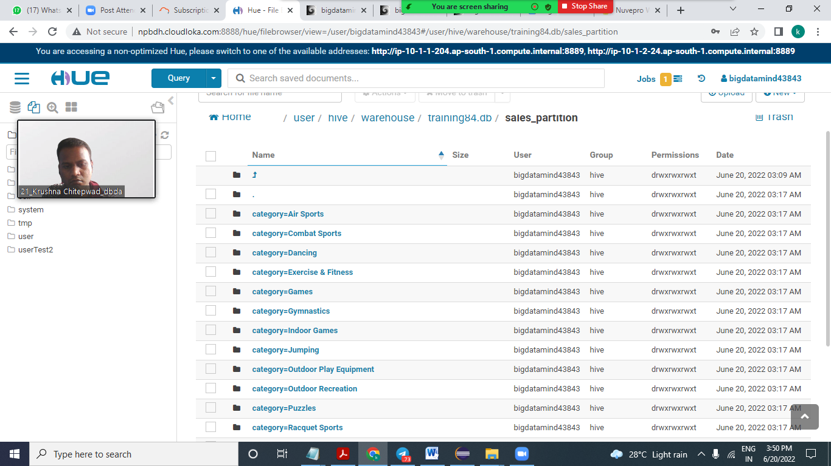

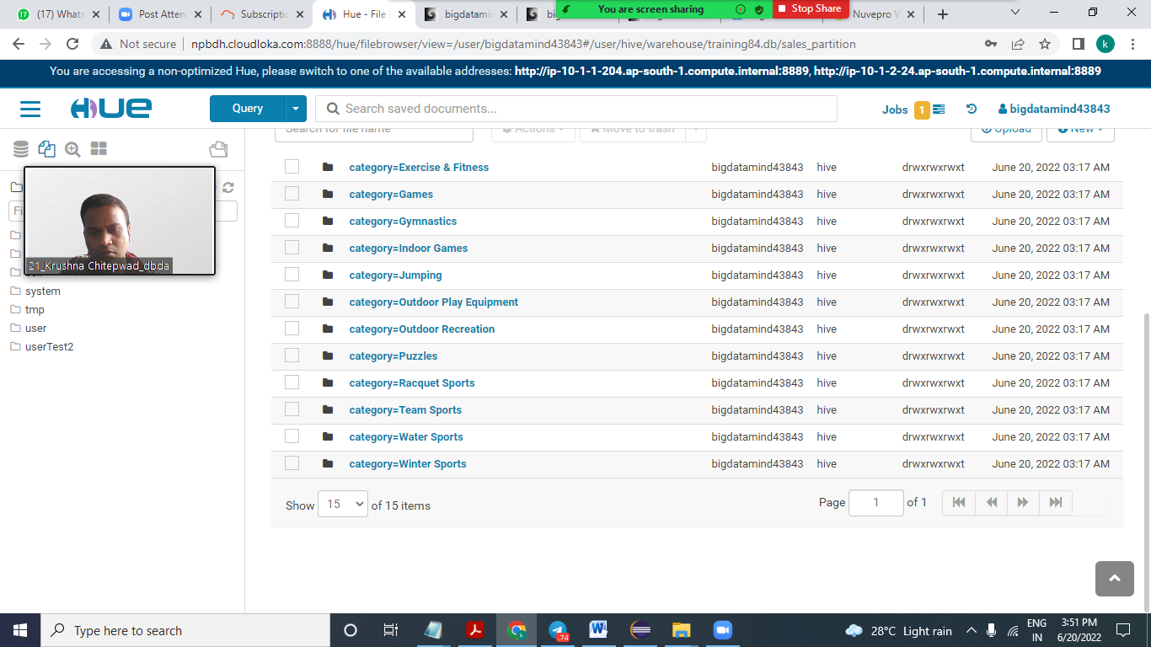

**Q1.**

**MapReduce**

**Question 2 : Find all time High price for each stock**

